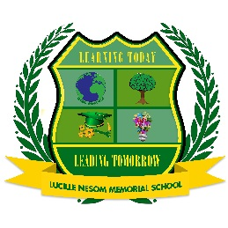Parent/Student/Teacher/Administrator Compact and Statement of Compliance
Lucille Nesom Memorial School
14417 Highway 442 West
P.O. Box 280, Tickfaw, LA 70466
985.345.2166 (O)
985-345-3731 (F)
In compliance with the Louisiana R. S. 17.235.2 and the ESSA relative to commitments by school students and their parents or guardians, the Sumner Middle School has written a signed statement of compliance as required by these laws. This compliance statement is in regard to school attendance, homework assignments, and school rules.
Student Agreement | Parent/Guardian Agreement | Teacher/Principal Agreement
As a student, I agree to the following:  1. I will attend school daily, except when absent for reasons due to illness or other excused absence.  2. I will arrive at school on time each day.  3. I will demonstrate significant effort toward completing all required homework assignments.  4. I will follow School and Classroom rules. | As a parent/guardian, I agree to the following:  1. I will ensure that my child attends school daily except for reasons specified in A.1 of the student agreement.  2. I will ensure that my school will arrive at school on time each day.  3. I will ensure that my child will complete his or her homework assignments.  4. I will attend all required parent and teacher or principal conferences. | As a Teacher/Principal, I agree to the following:  1. I agree to be available throughout the school year to answer questions relative to the statement of compliance.  2. I agree to support success of students in school.  3. I agree to provide students with a high-quality curriculum in an environment conducive to learning.  4. I agree to notify parent of student progress and attendance.
Signature of Student  Agreement : Date: | Signature of Parent/Guardian  Agreement : Date: | Signature of Teacher  Agreement : Date:  Signature of Principal  Agreement : Date:

